1. **Association learing steps**

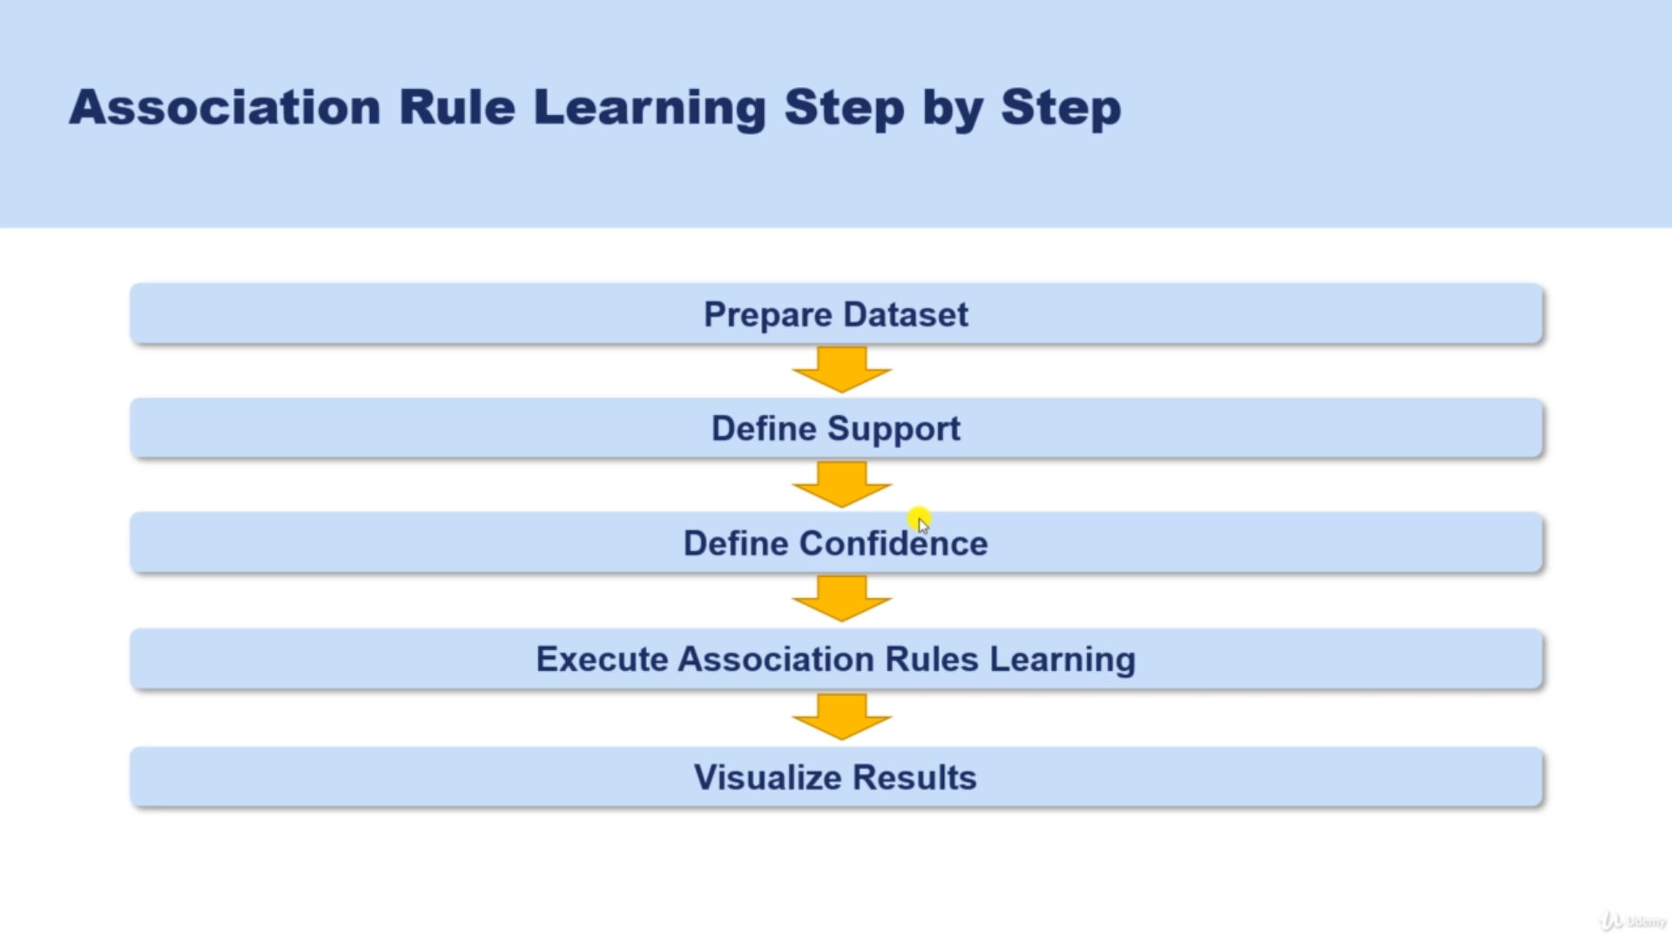

1. **Association learing related libraries**

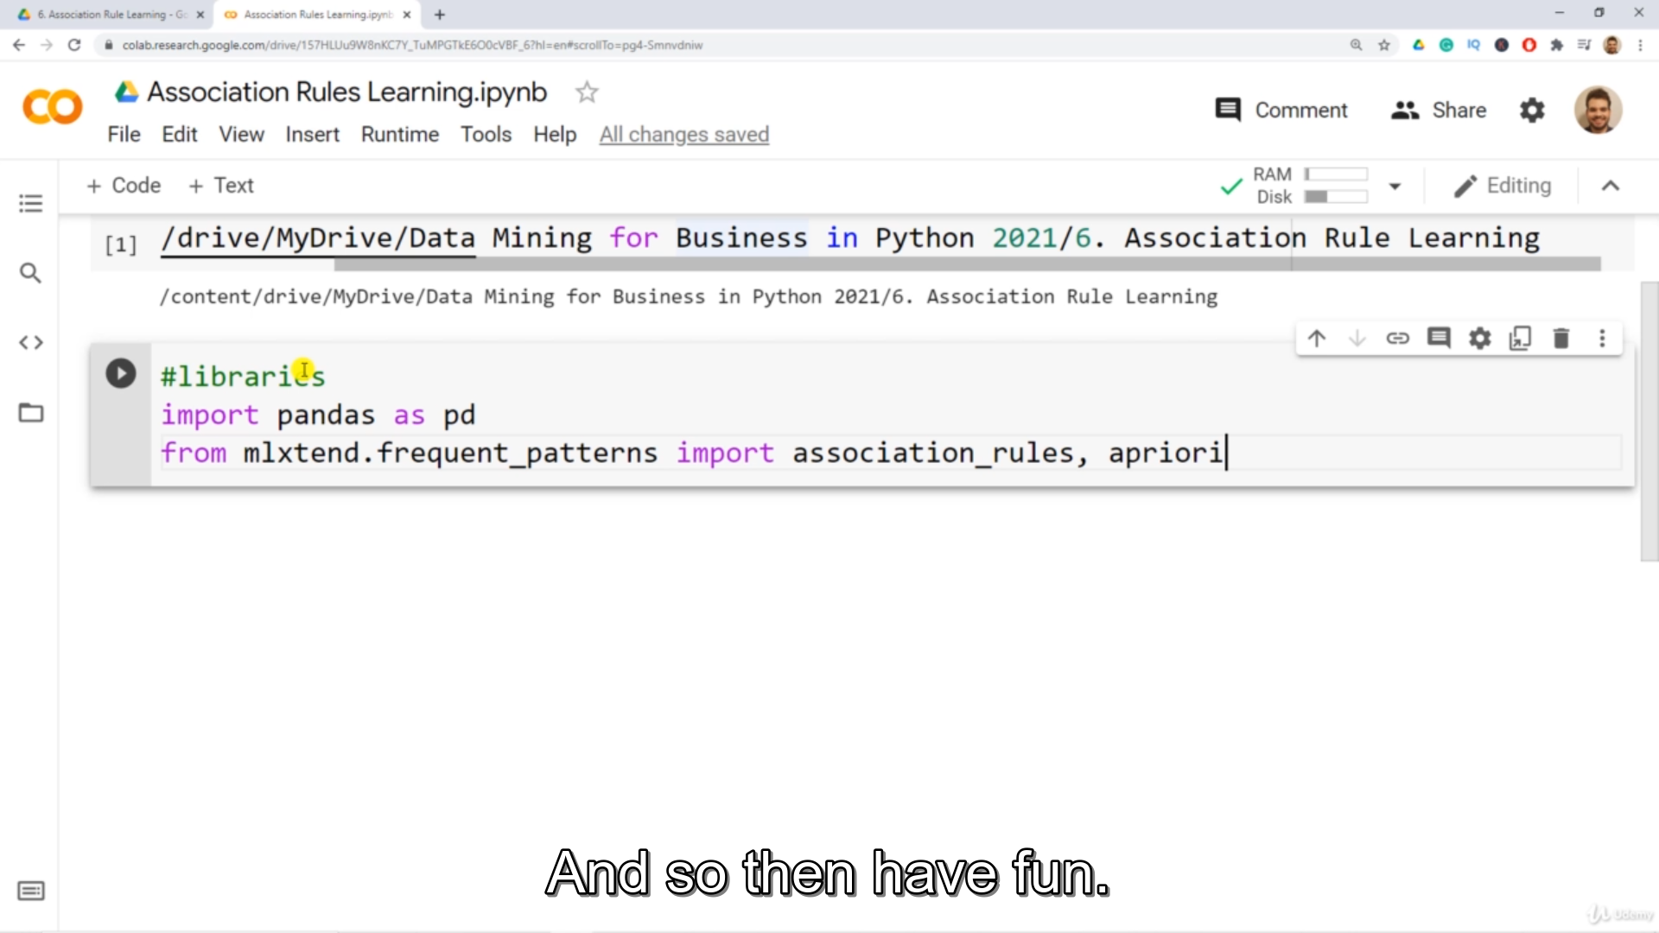

1. **Data set is also unique, Ex: Purchased items, Watched Movies, Clicked links [Recommender system]**

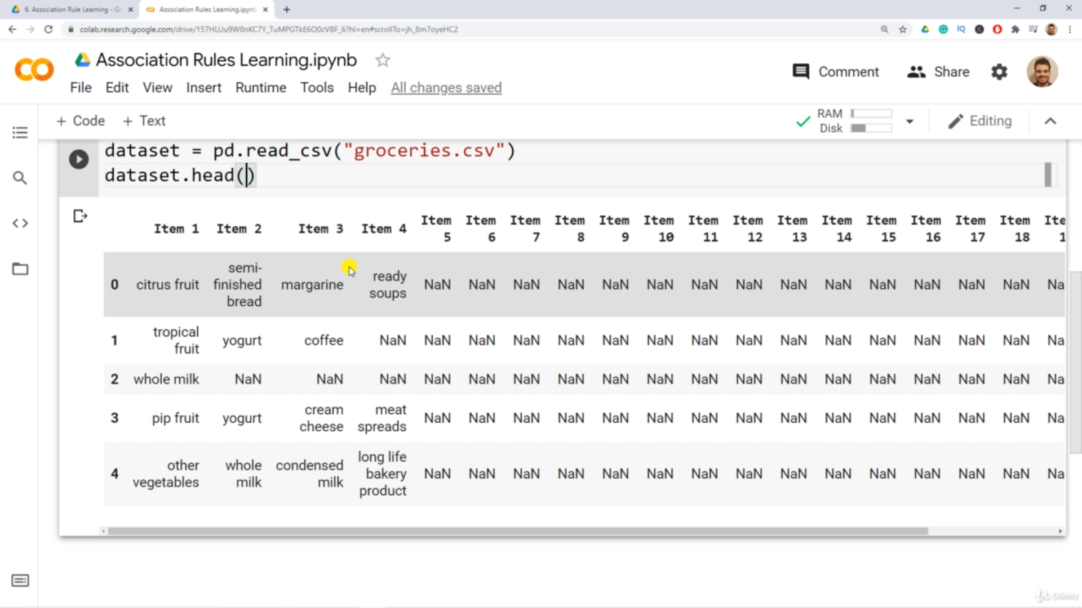

1. **Out Put of the Association Rule Learning is IF A, then B**

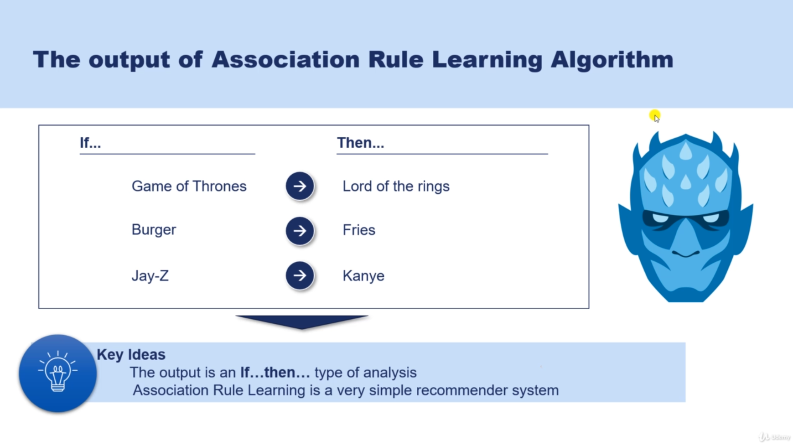

1. **Terminology 1 -Support**

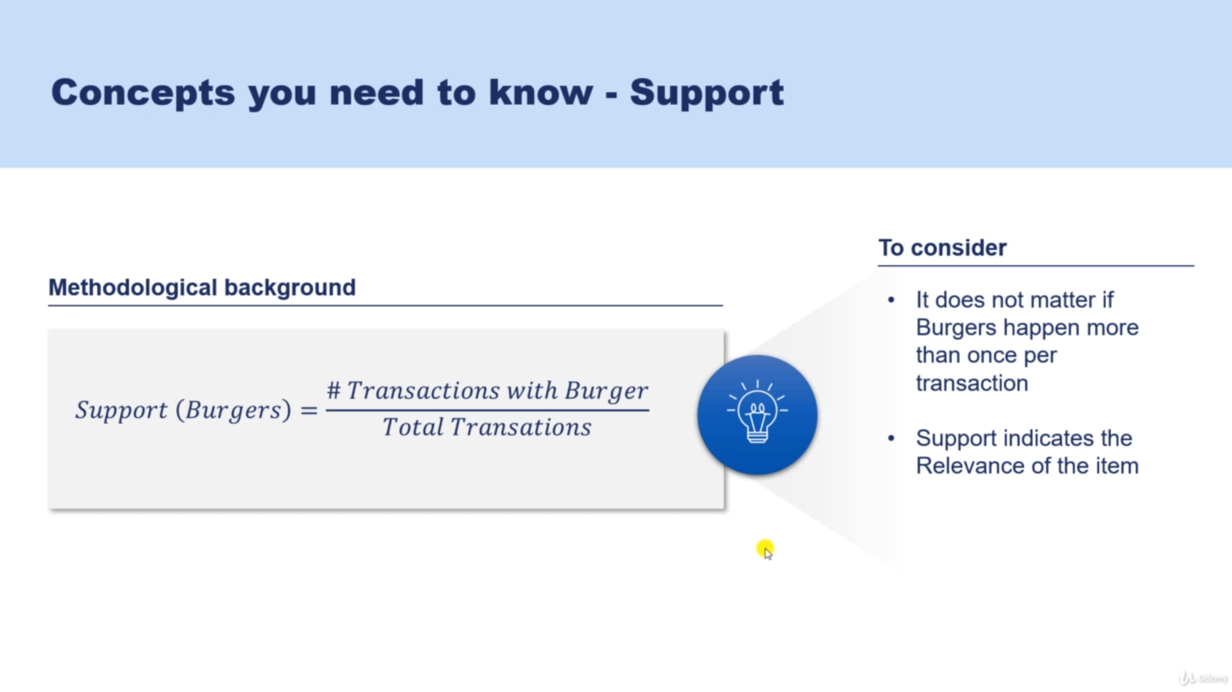

1. **Terminology 2 – Confidence**

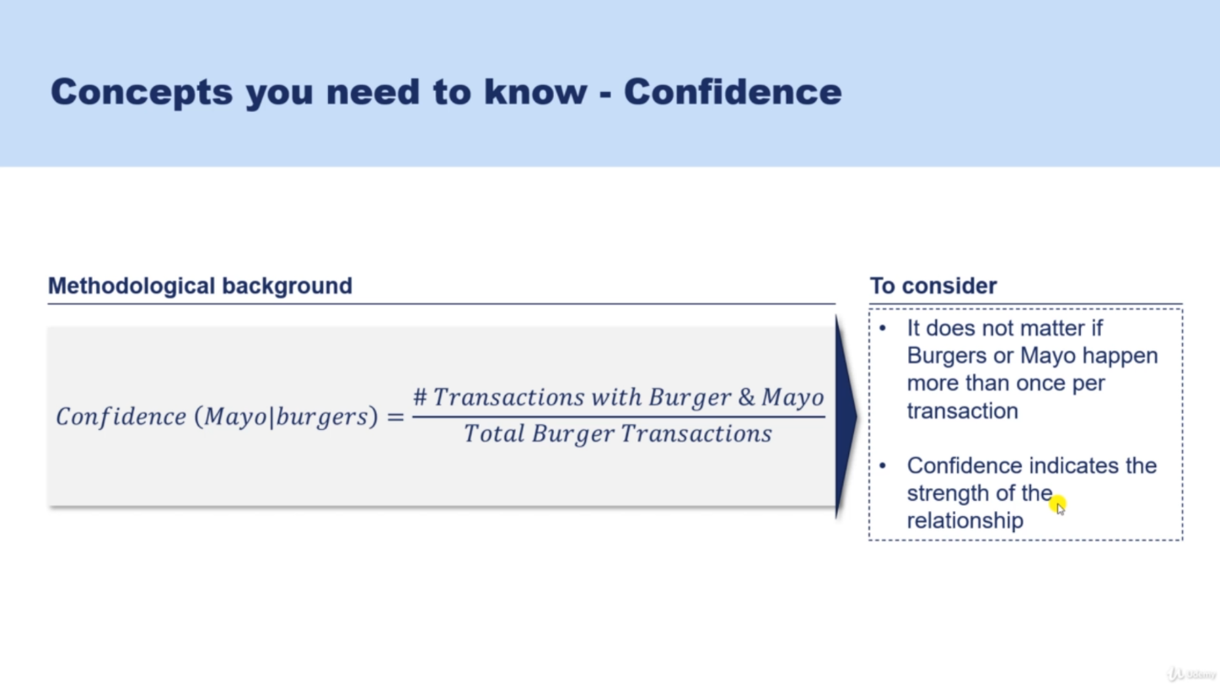

1. **Terminology 3 – Lift**

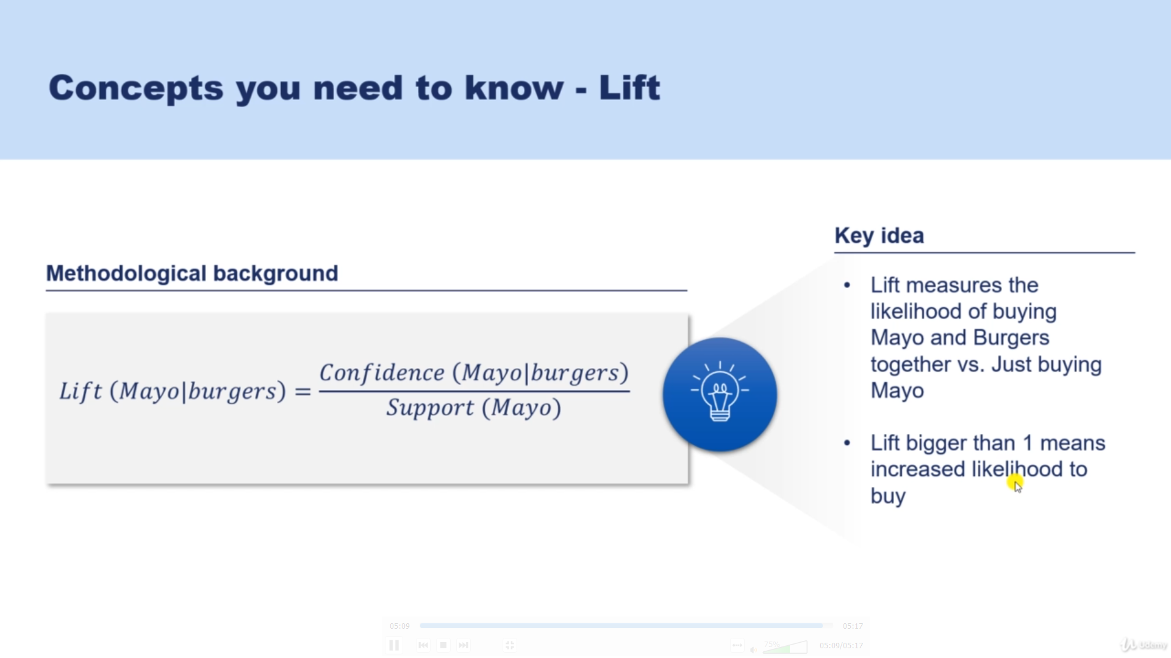

Lift(Mayno/burger) > 1 – With mayno customers buy burger

Lift(Mayno/burger)<1 – Only going to buy mayno

1. **Preparing data To fit into Association analysis**
2. Add each rows in a single list (Because Transaction encoder requires this format)

|  |  |  |  |
| --- | --- | --- | --- |
| Item1 | Item2 | Item3 | Item4 |
| Itema | itemb | Itemc | Itemd |

List=[[item1,item2,item3,item4],[itema,itemb,itemc,itemd]]

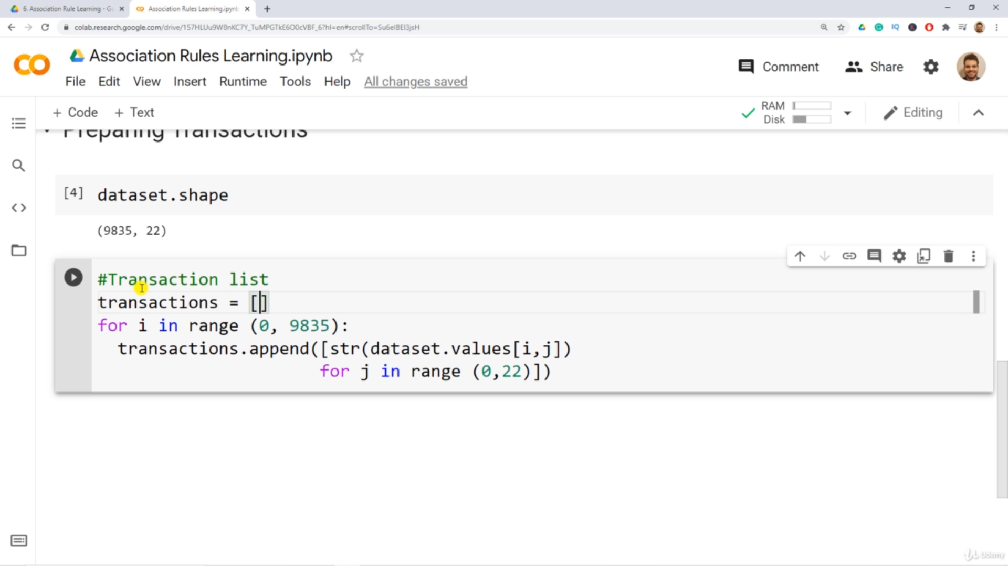

1. Encoding data

Convert data for Association analysis -> convert in to boolean Format

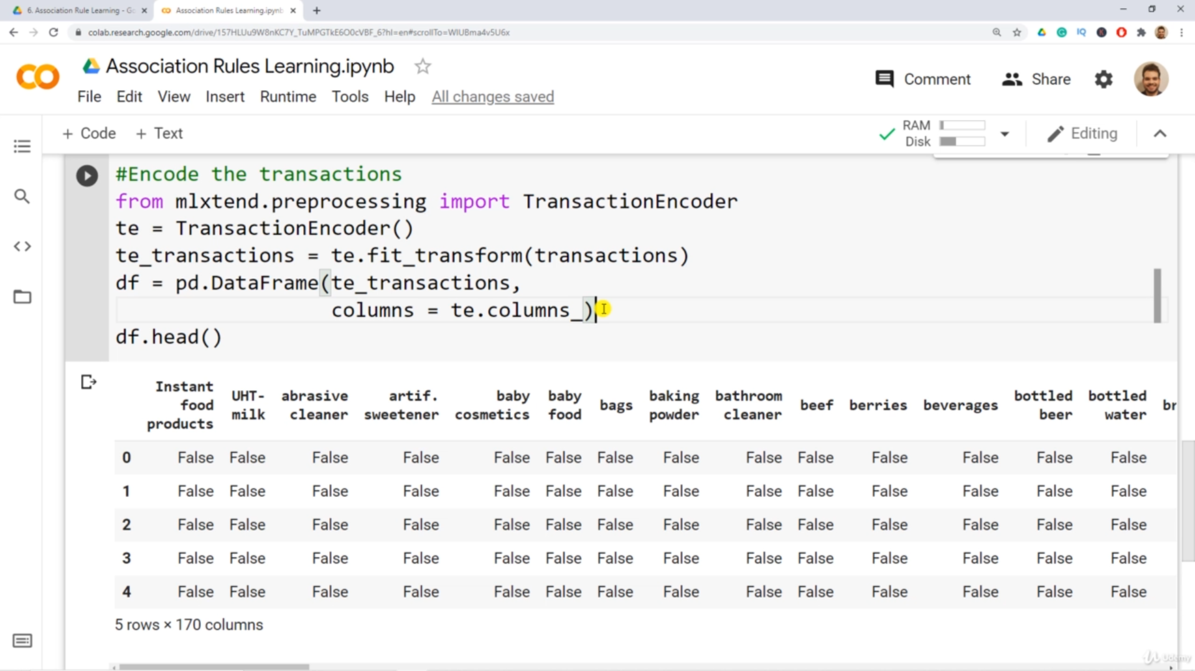

Encoded Data Frame

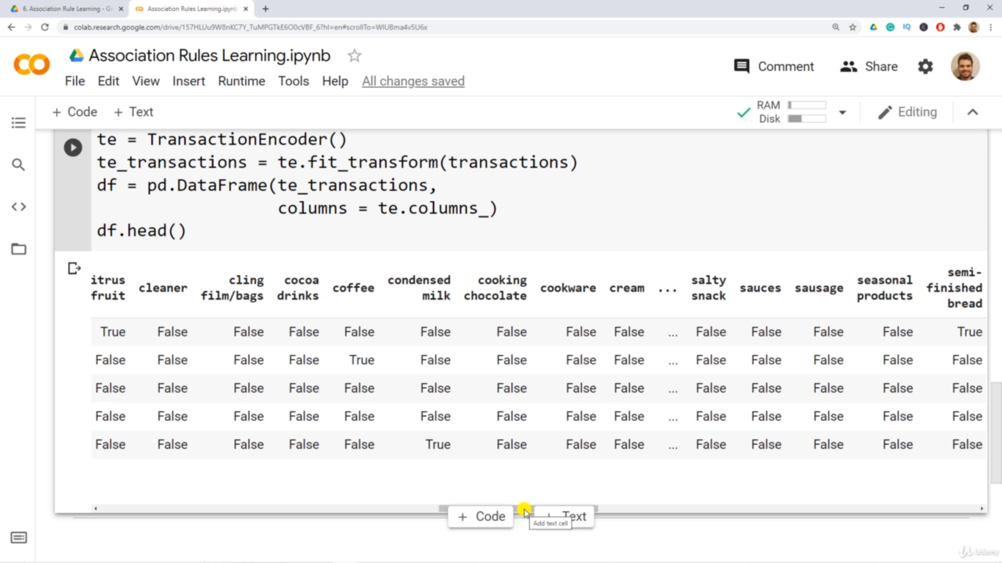

1. Apriori Algorithum

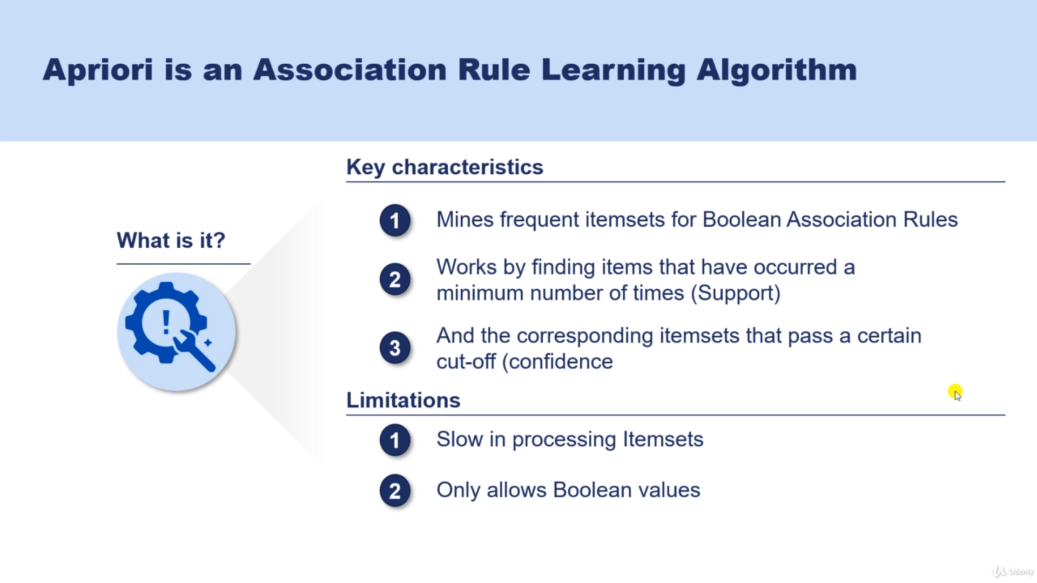

1. **Association rule Learning using Apriori algo**

He uses the the DF , that not encoded one

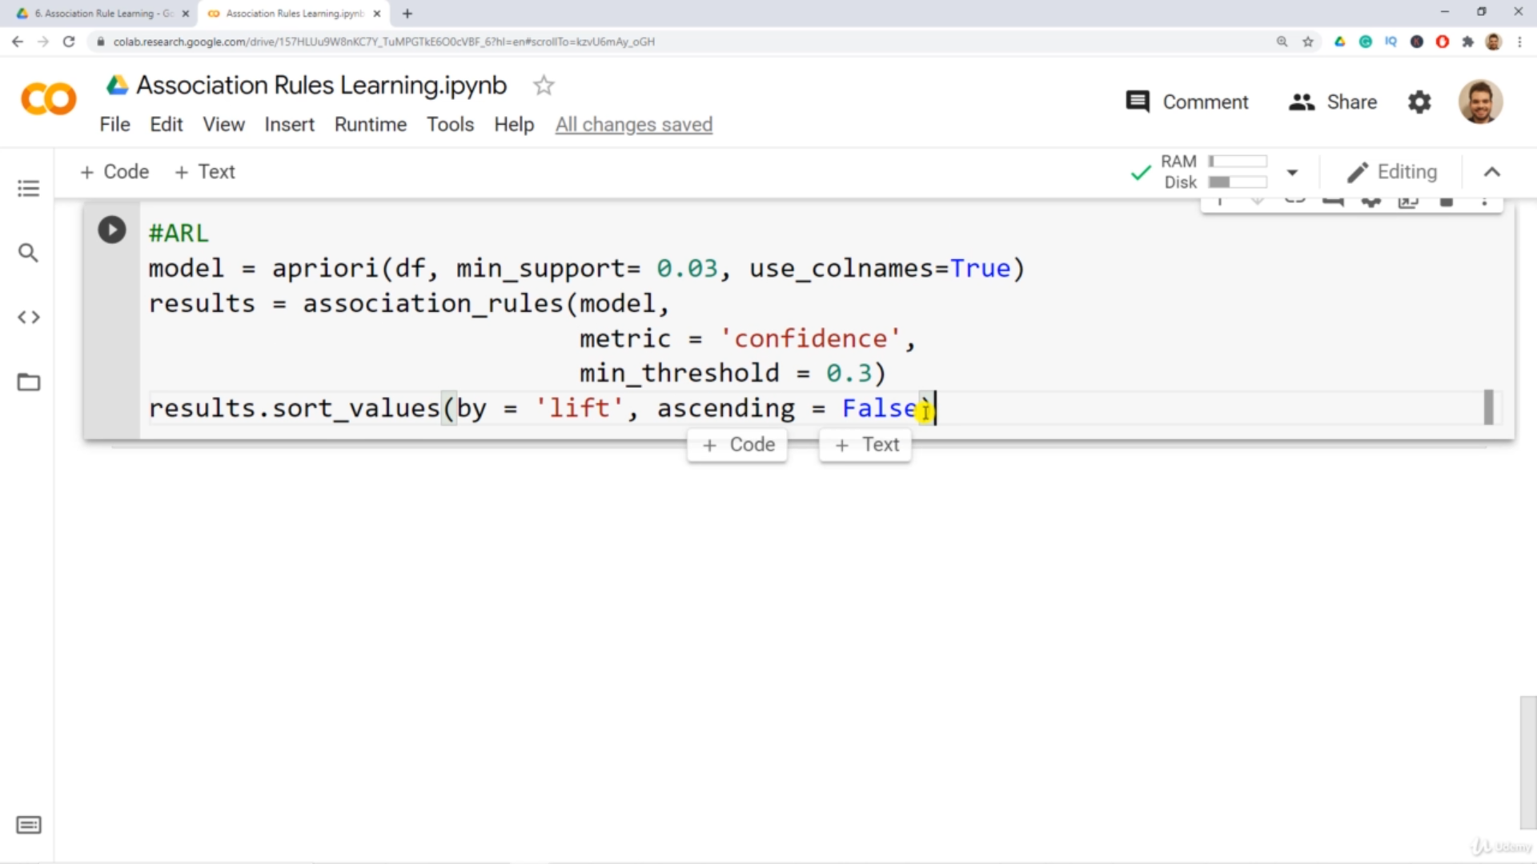

1st line -> used the data(not encoded One) , filters the data using support threshold

2nd line-> fetch assocuation rules(hidden details) By using confidence metric with min threshold (can use other metric as well)

3rd line-> Sort the association rules Order by lift

1. Output / studied rules

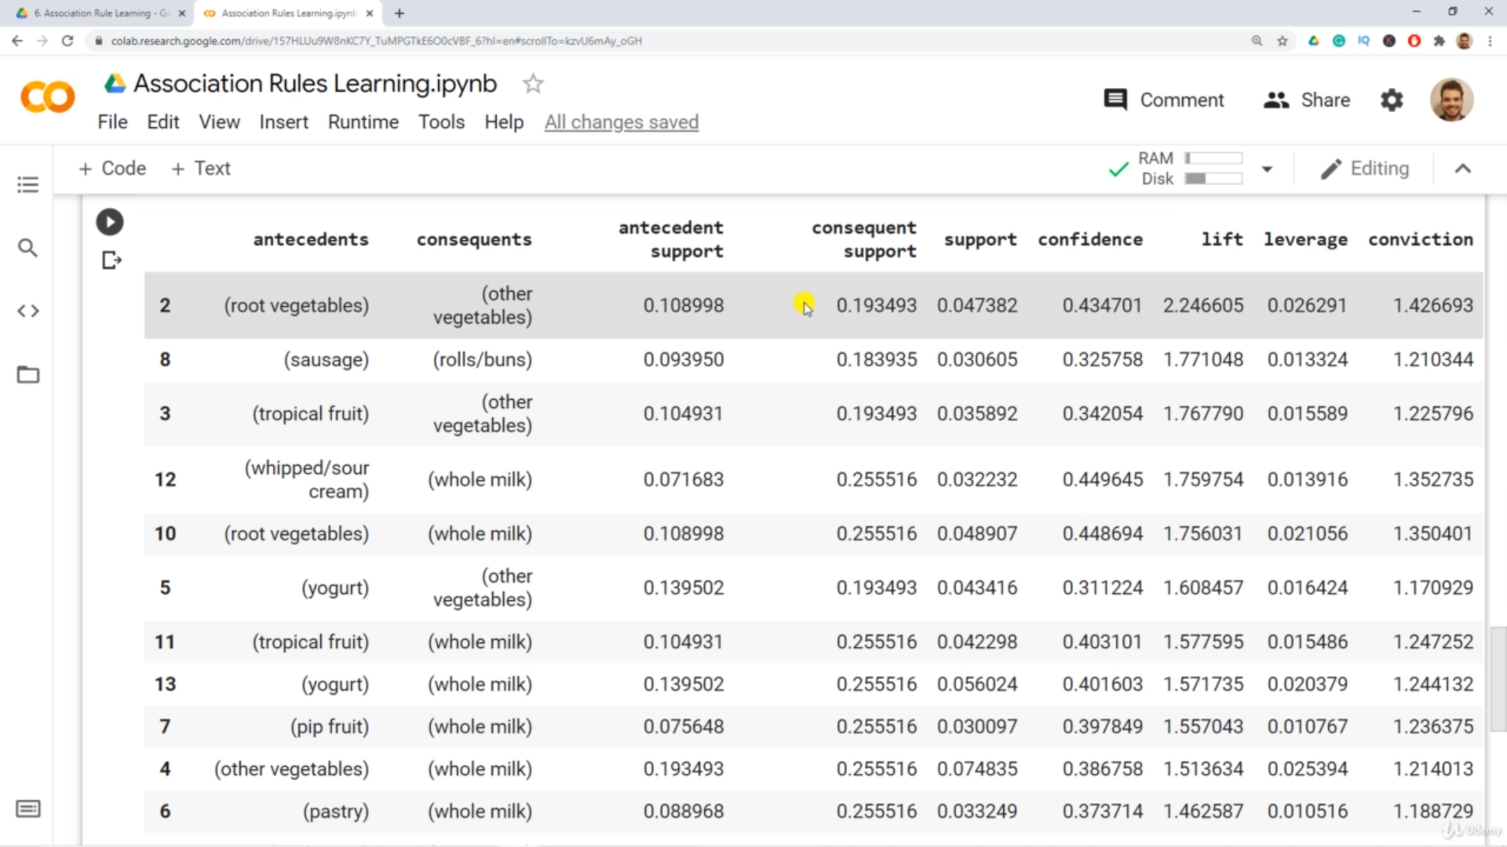

Some rules : If (root vegetables) -> then(other vegetables)

If(sausage) -> then(rolls/buns)

1. Results as visual

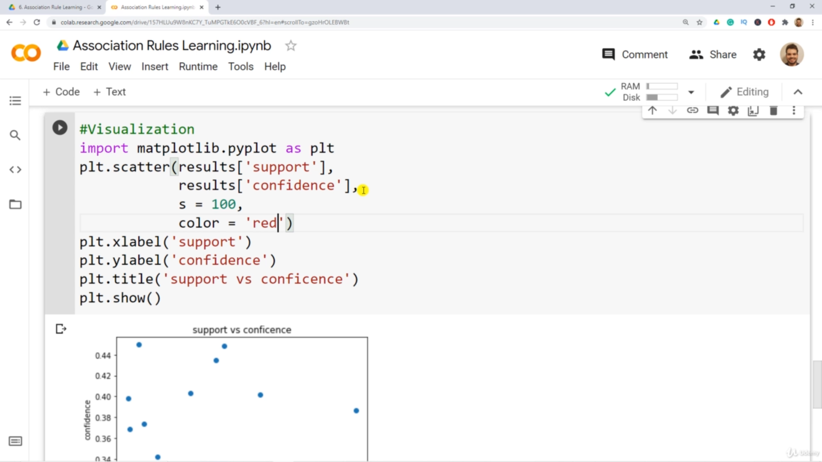

Just he visualized confidence vs support -> Nothing useful